Final Project Report

1. Application Overview

Project Title
Automation Exercise – E-Commerce Testing

Application Description
Automation Exercise is an e-commerce web application that allows users to register, log in, browse products, search for products, add products to the cart, proceed to checkout, and place orders.

Project Objective
The objective of this project is to perform manual testing, automation testing, API testing, and AI-based testing to verify the functionality of the application and identify defects.

Application Under Test
https://www.automationexercise.com

Testing Scope
- Registration and Login
- Product Search and Product Details
- Shopping Cart
- Checkout and Payment
- Order Confirmation
- Logout

Testing Types
- Manual Testing
- Functional Testing
- Positive and Negative Testing
- Regression Testing
- Automation Testing
- API Testing
- AI-assisted Testing
Home Page Screenshot
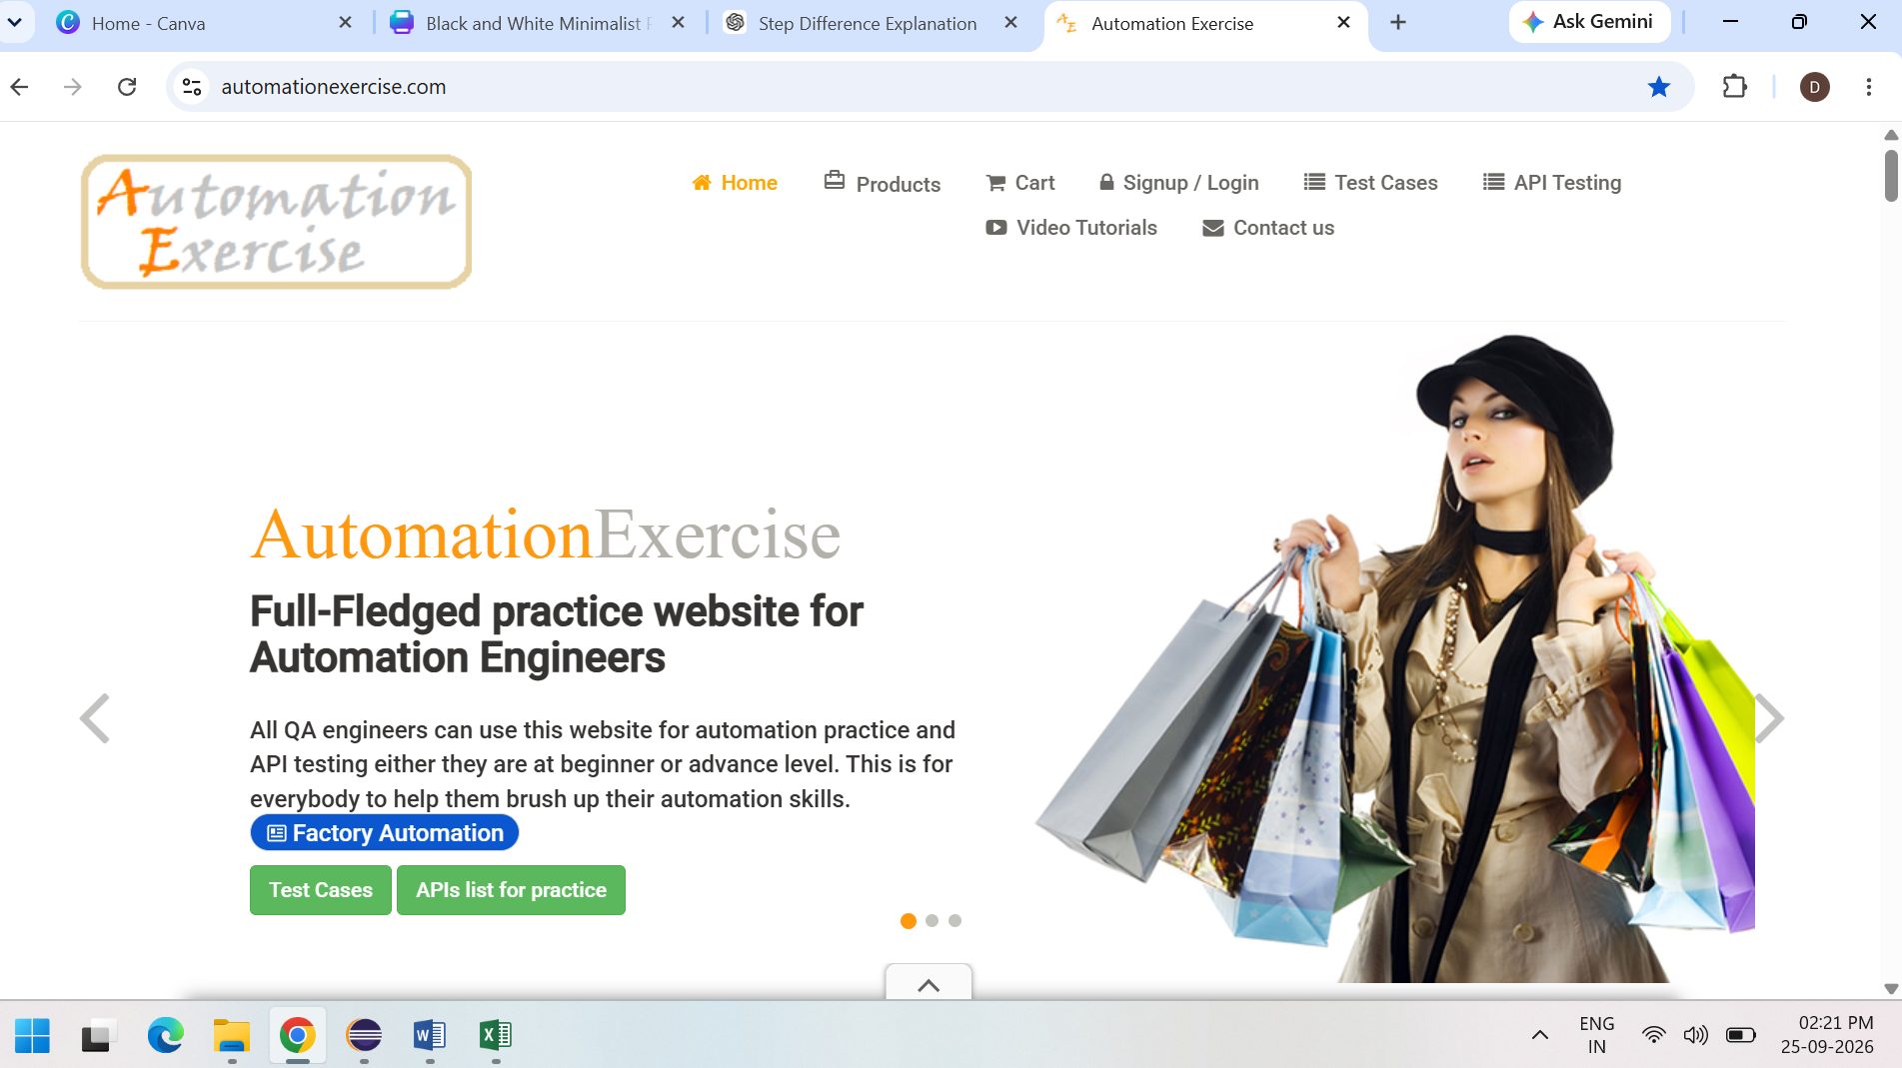

Manual Testing Summary

Manual testing was performed on the Automation Exercise e-commerce application to verify its functionality and identify defects.

Testing Activities
- Prepared test scenarios and test cases.
- Executed positive and negative test cases.
- Compared actual results with expected results.
- Recorded test execution status.
- Documented defects identified during testing.

Modules Tested
Registration, Login, Products, Search, Product Details, Cart, Checkout, Payment, Order Confirmation, and Logout.

Test Documentation
- Test Plan
- Test Scenarios
- Test Cases
- Test Execution Results
- Defect Details, where applicable
- Screenshots as evidence

Test Execution Summary
Total Test Cases Executed: [51]
Passed: [51]
Failed: [0]
Blocked: [0]

Defect Tracking
Defects identified during testing were documented in the test execution sheet, where applicable.

Conclusion
Manual testing helped verify the functionality of the application and identify issues in the tested modules.
Test Case Screenshot
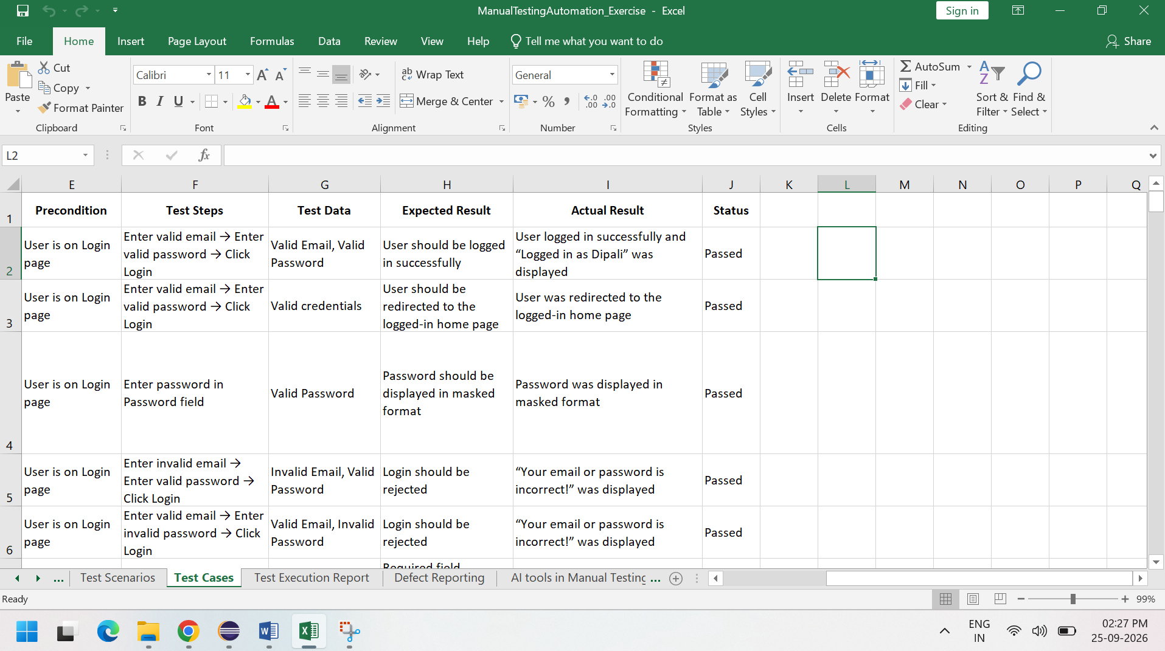
Test Execution Report

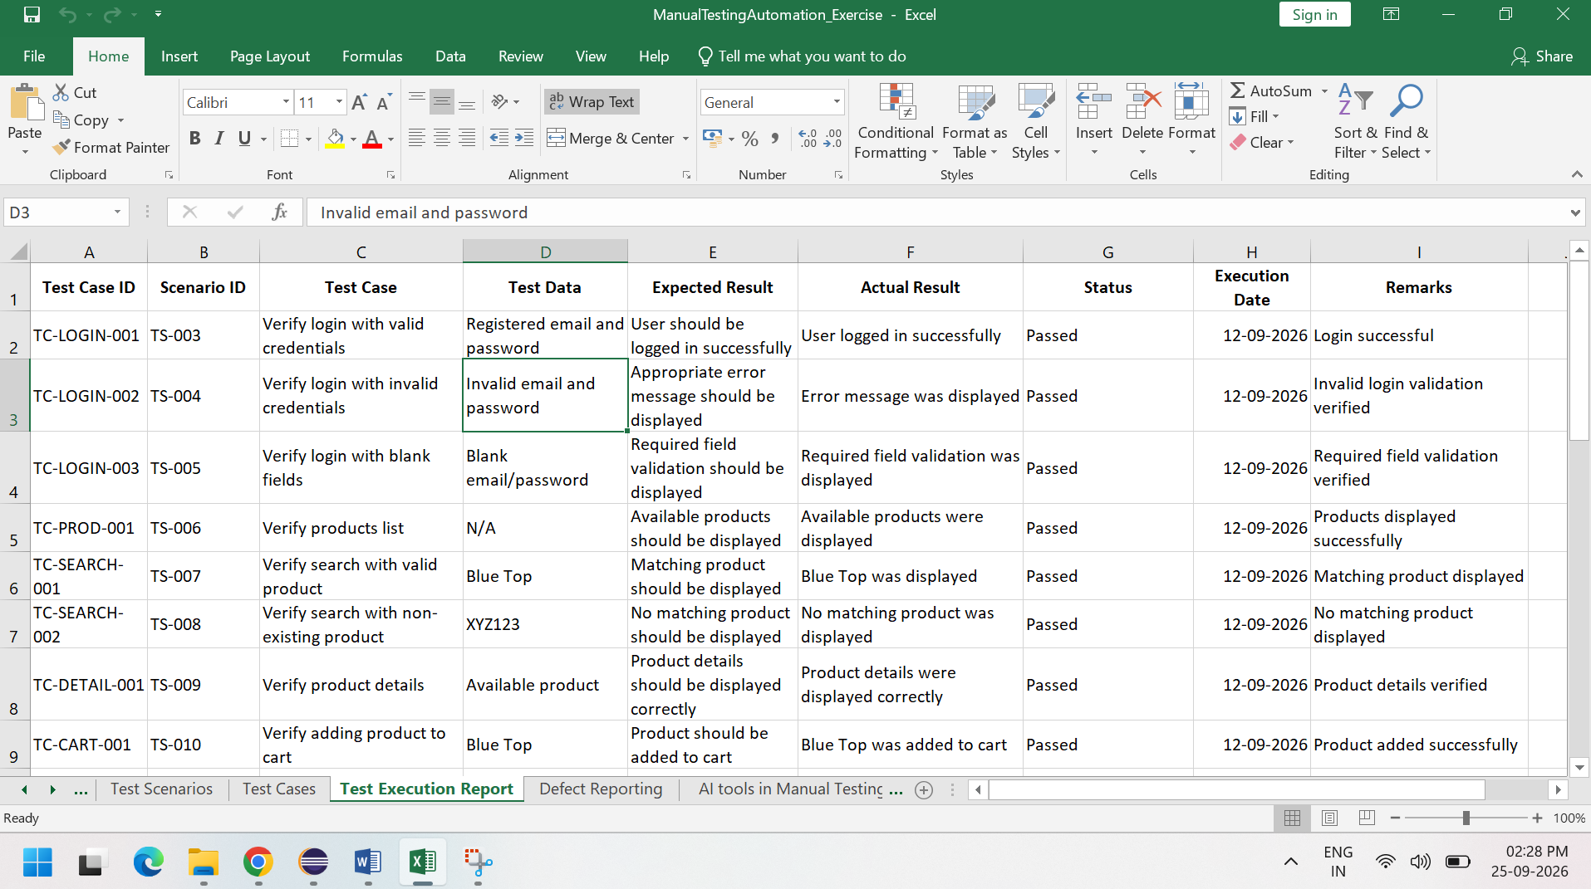

- Automation Framework Design

Automation Framework Design
For this project, a TestNG-based Automation Framework was implemented using Java and Selenium WebDriver.
TestNG was selected for test execution, test organization, assertions, annotations, and reporting support.

Framework Components
- Java – Programming language
- Selenium WebDriver – Web browser automation
- TestNG – Test execution and test management
- Maven – Dependency management and project build
- Page Object Model (POM) – Page-level code organization
- WebDriverManager – WebDriver management
- Log4j – Logging
- Extent Reports – Test execution reporting

Framework Flow
TestNG Test Classes → Page Classes → Selenium WebDriver → Application → Assertions → Reports

Deliverable
A TestNG-based Selenium automation framework was created for automating selected e-commerce test scenarios.

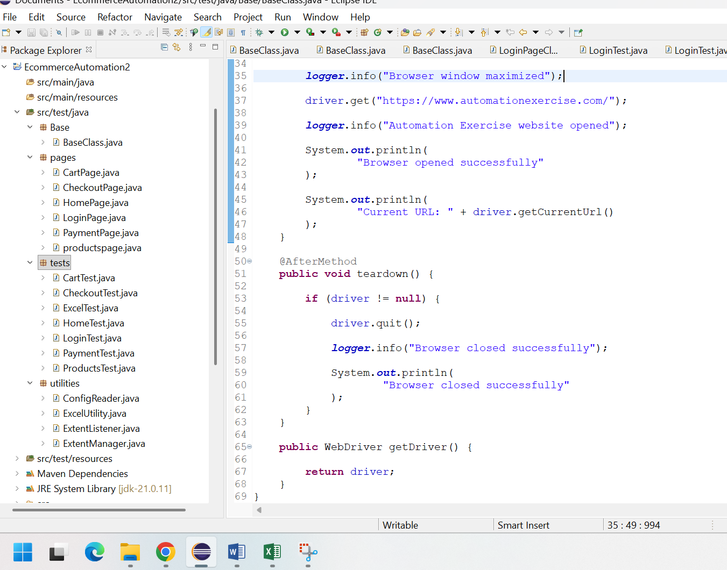

Maven Project Setup
A Maven project was created to manage the automation project dependencies and build configuration.
The required dependencies and plugins were configured in the pom.xml file.

Dependencies Used
- Selenium WebDriver
- TestNG
- WebDriverManager
- Apache POI
- Log4j
- Extent Reports

Maven Benefits
Maven helps manage project dependencies, maintain the project structure, and execute the automation tests through the Maven build lifecycle.

Deliverable
The Maven project contains the pom.xml file, source code, test classes, page classes, utilities, and configuration files.

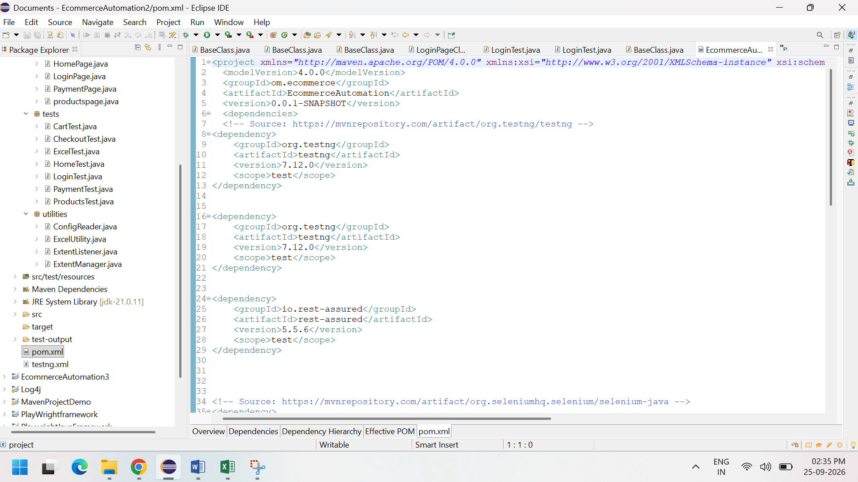

Page Object Model (POM)
The Page Object Model (POM) design pattern was implemented to improve code reusability, readability, and maintainability.
Separate page classes were created for different application modules.

Page Classes
- LoginPage
- ProductsPage
- CartPage
- CheckoutPage
- PaymentPage

POM Implementation
The page classes contain:
- Web element locators
- Page actions
- Reusable methods
Selenium By locators were used to identify web elements.
Test classes use the page methods to perform actions on the application instead of directly writing locators in every test case.

Example Workflow
LoginTest → LoginPage → Locators & Actions → Application

Deliverable
Page Object Model classes were implemented for the major modules of the application.

Utilities & Configurations
Reusable utility components were created to support the automation framework and reduce code duplication.

Utilities Used
- WebDriver management
- Screenshot utility
- Extent Report utility
- TestNG Listener
- Logging utility

Configuration
The project configuration and reusable framework settings were maintained separately where applicable.

Excel Utility
Apache POI was included in the Maven project to support Excel-based test data handling.

Deliverables
- Utility classes
- Configuration files, where applicable
- Excel utility, where applicable

Test Execution & Reporting
The automated test cases were executed using the TestNG framework.
Assertions were used to validate the expected and actual results during test execution.

Test Execution
The following test classes were created for the application:
- LoginTest
- HomeTest
- ProductsTest
- CartTest
- CheckoutTest
- PaymentTest

Reporting
The framework generates test execution results using:
- TestNG Reports
- Extent Reports

Logging
Log4j was used for logging important test execution information and debugging purposes.

Failure Screenshots
Screenshots were captured for failed test cases using the TestNG listener and screenshot functionality.

Test Execution Flow
TestNG Test Suite
↓
Test Class Execution
↓
Selenium WebDriver
↓
Assertions
↓
Test Result
↓
Extent Report / TestNG Report
↓
Failure Screenshot (when applicable)

Deliverables
- Test execution results
- Extent Report
- TestNG report
- Execution logs
- Failure screenshots

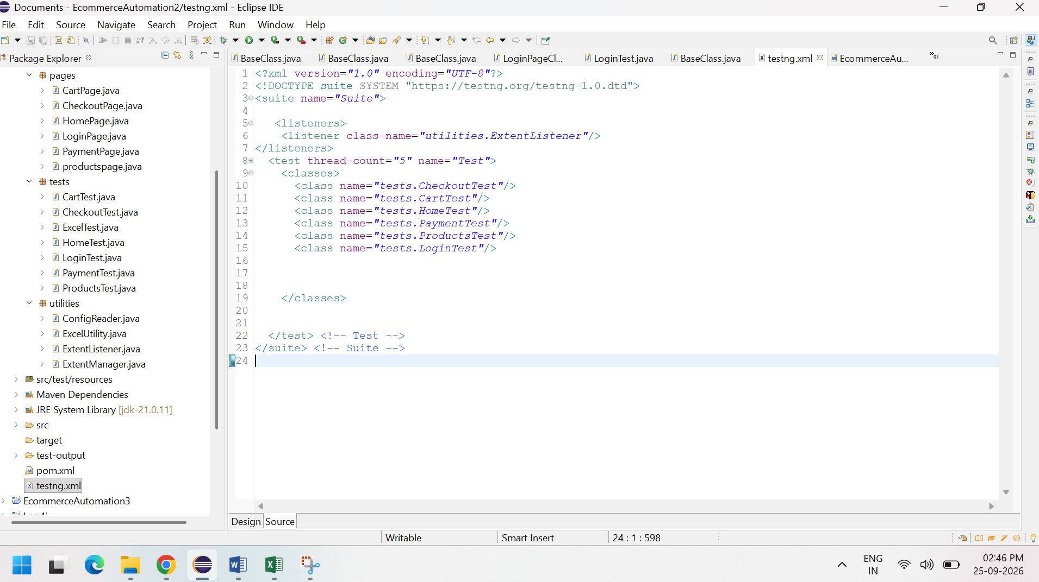
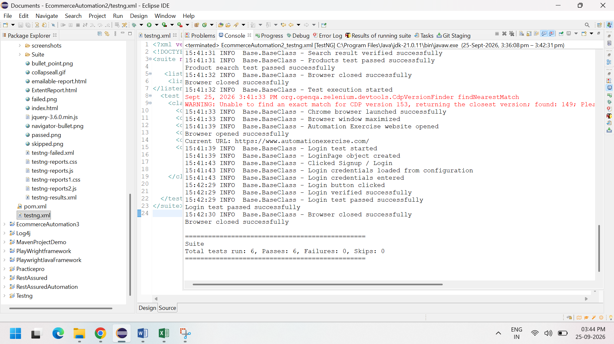

API Testing Results

1. API Testing Overview
API Testing was performed to verify the functionality and behavior of REST APIs. The APIs were tested using Postman and automated using Rest Assured with Java and TestNG in Eclipse IDE.
The following validations were performed:
- Response Status Code
- Response Headers
- Response Body
- Expected API response data

2. Tools Used
- Postman – Used for manual API testing.
- Eclipse IDE – Used to develop and execute API automation scripts.
- Java – Used as the programming language for Rest Assured scripts.
- Rest Assured – Used for API automation testing.
- TestNG – Used for test execution and assertions.

3. APIs Tested
The following HTTP methods were covered during API testing:
- GET – Retrieve user information.
- POST – Register a new user.
- PUT – Update existing user information.
- DELETE – Delete a user.

4. GET API Testing
Test Scenario: Retrieve users from the API.
Validation Performed:
- Verified the response status code.
- Verified the Content-Type response header.
- Verified that the response body contains user data.
- Verified that the user data is not empty.
Expected Result:
- Status code should be 200 OK.
- Response should be in JSON format.
- User data should be available in the response body.
Result: Passed

5. POST API Testing
Test Scenario: Register a new user using the API.
Validation Performed:
- Verified the response status code.
- Verified the Content-Type response header.
- Verified that the response contains a user ID.
- Verified that the response contains a registration token.
Expected Result:
- Status code should be 200 OK.
- Response should be in JSON format.
- User ID and token should be returned successfully.
Result: Passed

6. PUT API Testing
Test Scenario: Update existing user information.
Validation Performed:
- Verified the response status code.
- Verified the Content-Type response header.
- Verified the updated user name.
- Verified the updated job details.
Expected Result:
- Status code should be 200 OK.
- Response should be in JSON format.
- Updated user details should be returned correctly.
Result: Passed

7. DELETE API Testing
Test Scenario: Delete an existing user.
Validation Performed:
- Sent a DELETE request to the user endpoint.
- Verified the HTTP response status code.
Expected Result:
- API should successfully process the delete request.
- Expected status code should be 204 No Content.
Result: Tested

8. API Validation Summary
- Response Code Validation: Performed.
- Header Validation: Performed.
- Response Body Validation: Performed.
- GET API: Tested successfully.
- POST API: Tested successfully.
- PUT API: Tested successfully.
- DELETE API: Tested as part of the API testing scope.

9. Postman Testing
Postman was used to manually send API requests and verify the corresponding responses.
The following activities were performed in Postman:
- Created and sent API requests.
- Verified response status codes.
- Verified response headers.
- Verified response body.
- Captured API testing screenshots as evidence.
Postman Evidence:

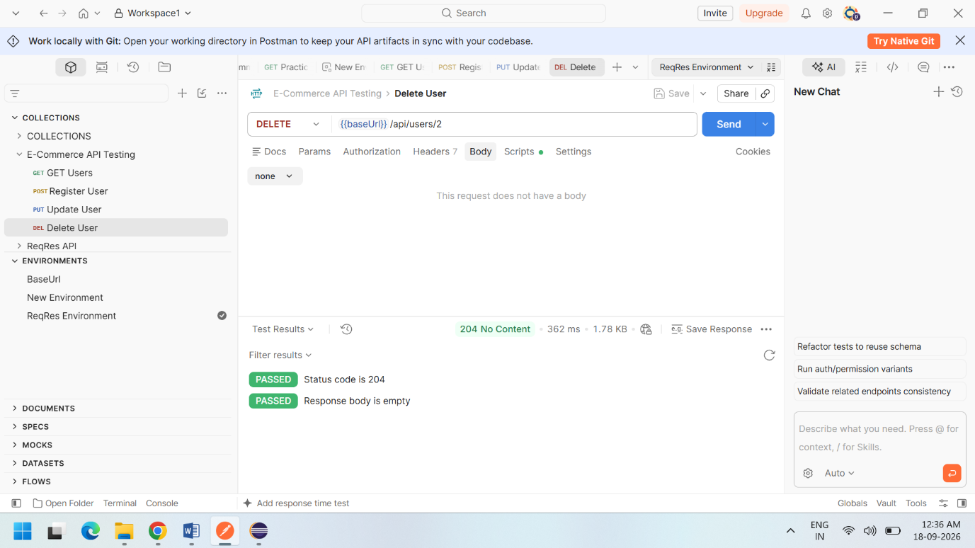

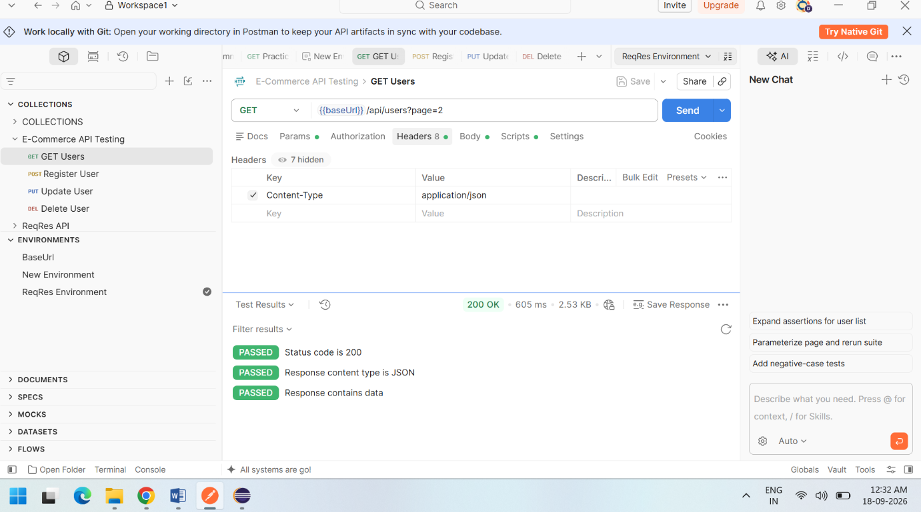

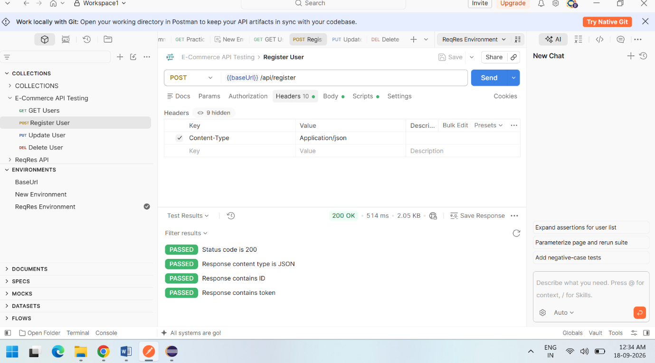

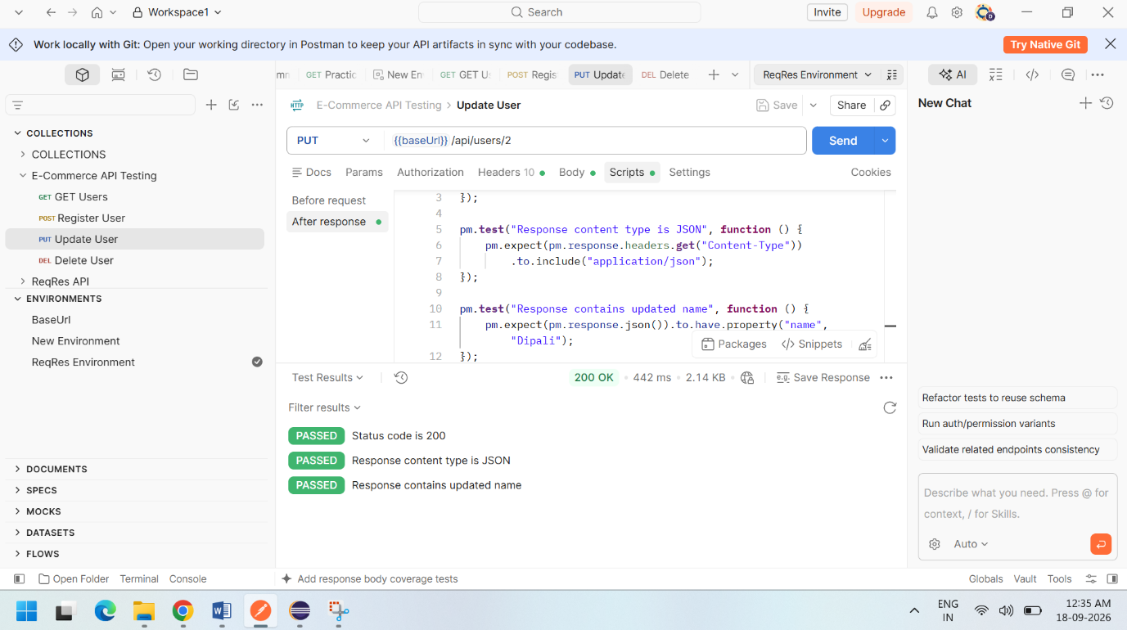

10. Rest Assured Automation
API automation was implemented in Eclipse IDE using Java, Rest Assured, and TestNG.
The automated tests covered:
- GET request validation.
- POST request validation.
- PUT request validation.
- Response status code assertions.
- Response header assertions.
- Response body assertions.
Eclipse/TestNG Evidence:
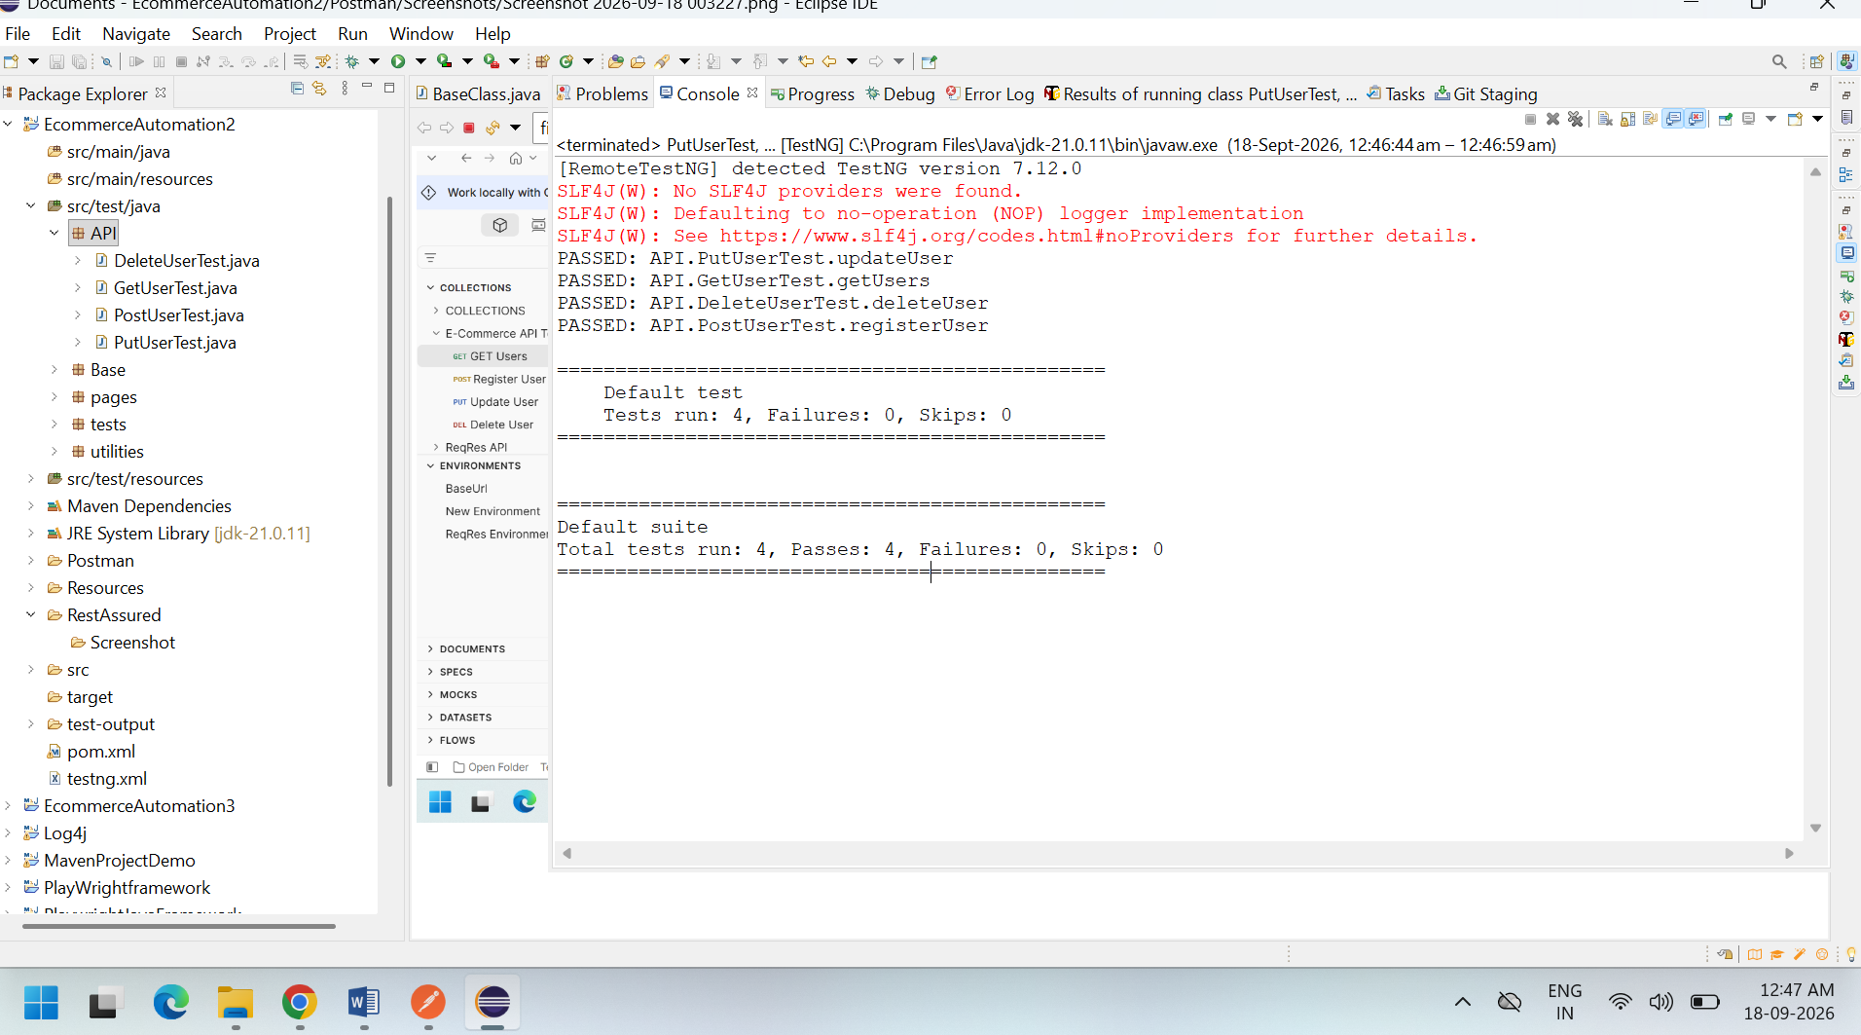

11. API Testing Conclusion
API testing was successfully carried out using Postman and Rest Assured. GET, POST, PUT, and DELETE operations were covered. Response codes, headers, and response body data were validated to ensure that the APIs behaved according to the expected requirements.
The Rest Assured API test scripts developed in Eclipse are included as part of the project deliverables.

- AI Tool Usage

Testim Automation – Login Test & Dashboard Validation

1. Task
Create an automated Login Test and validate the Dashboard/Home page using Testim.

2. Tool Used
- Testim

3. Application Under Test
- Automation Exercise

4. Test Performed
- Automated Login Test was created using Testim.
- Valid login credentials were entered.
- Login button was clicked.
- Dashboard/Home page was validated after successful login.

5. Test Result
- Login Test: PASS
- Dashboard Validation: PASS
- Overall Test Status: PASS

6. Evidence
- Login Test execution screenshot
- Dashboard/Home validation screenshot
- Successful test execution screenshot

7. Conclusion
The Login Test and Dashboard Validation were successfully created and executed using Testim. Both validations passed successfully.

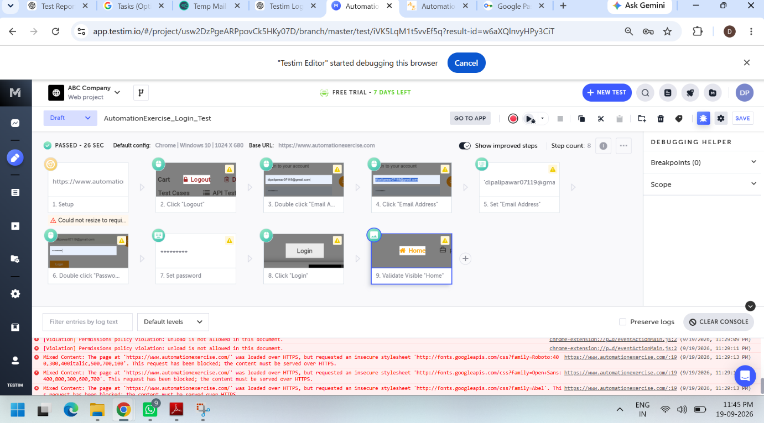
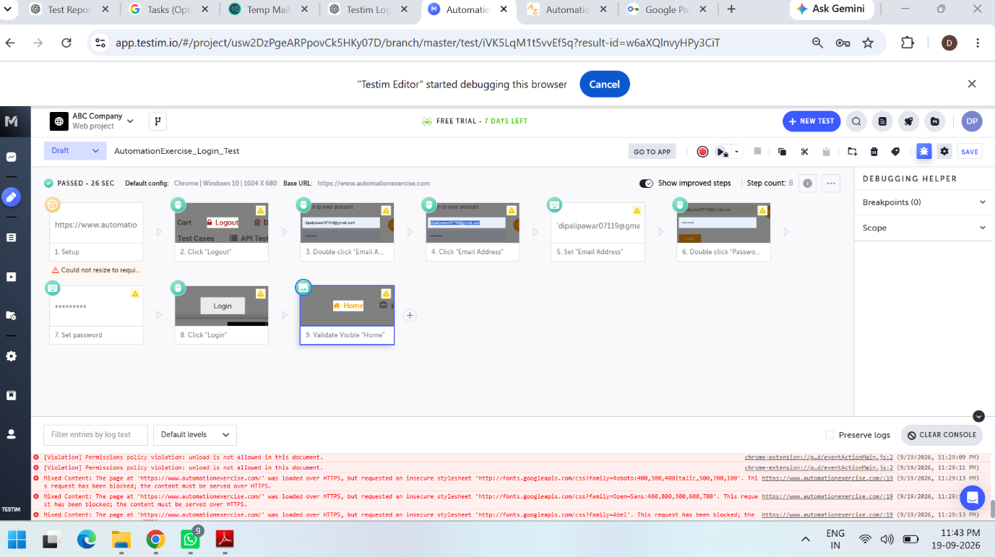

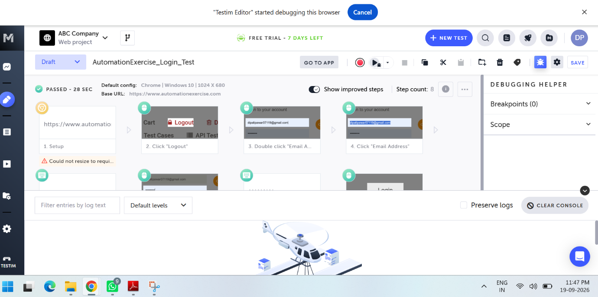

CI/CD Flow
Continuous Integration and Continuous Delivery (CI/CD) practices were implemented using GitHub, Maven, and Jenkins to automate the build and test execution process.

Tools Used
- GitHub – Source code repository and version control
- Maven – Build and dependency management
- Jenkins – Continuous Integration and automated test execution

CI/CD Workflow
Developer Code
↓
GitHub Repository
↓
Jenkins Job
↓
Maven Build
↓
Automated Test Execution
↓
Test Results / Reports

GitHub Integration
The complete testing project was maintained in a GitHub repository. The repository contains the manual testing documentation, Selenium automation project, API automation project, AI testing evidence, project report, and presentation.
GitHub Repository:
https://github.com/Dipali-dp/EcommerceTestingProject.git

Maven Build
Maven was used to manage project dependencies and execute the automation test suite.
The Selenium automation project was executed using the following Maven command:
mvn -f EcommerceAutomation2/pom.xml clean test
The pom.xml file contains the required dependencies and Maven configuration for the automation project.

Jenkins Configuration
A Jenkins job named Ecommerce-Automation was configured to retrieve the project from the GitHub repository and execute the Maven automation tests.
Jenkins was configured with the GitHub repository URL and the Maven build command.

Jenkins Test Execution
Jenkins successfully executed the Selenium automation project through Maven. The test execution console displayed the automated test execution and results.
The Jenkins job was also configured to publish JUnit test results for reviewing the test execution status.

API CI/CD Execution
A separate Jenkins job was configured for the API automation project. The API automation tests were developed using Rest Assured, Java, and TestNG and executed through Maven in Jenkins.

CI/CD Result
The CI/CD setup successfully demonstrated automated test execution using GitHub, Maven, and Jenkins. This setup helps reduce manual execution effort and provides a repeatable process for running automated tests and reviewing test results.

Evidence
- GitHub Repository Screenshot
- Jenkins Job Configuration Screenshot
- Jenkins Build Console Screenshot
- Jenkins Test Execution Result Screenshot
- Maven pom.xml Screenshot

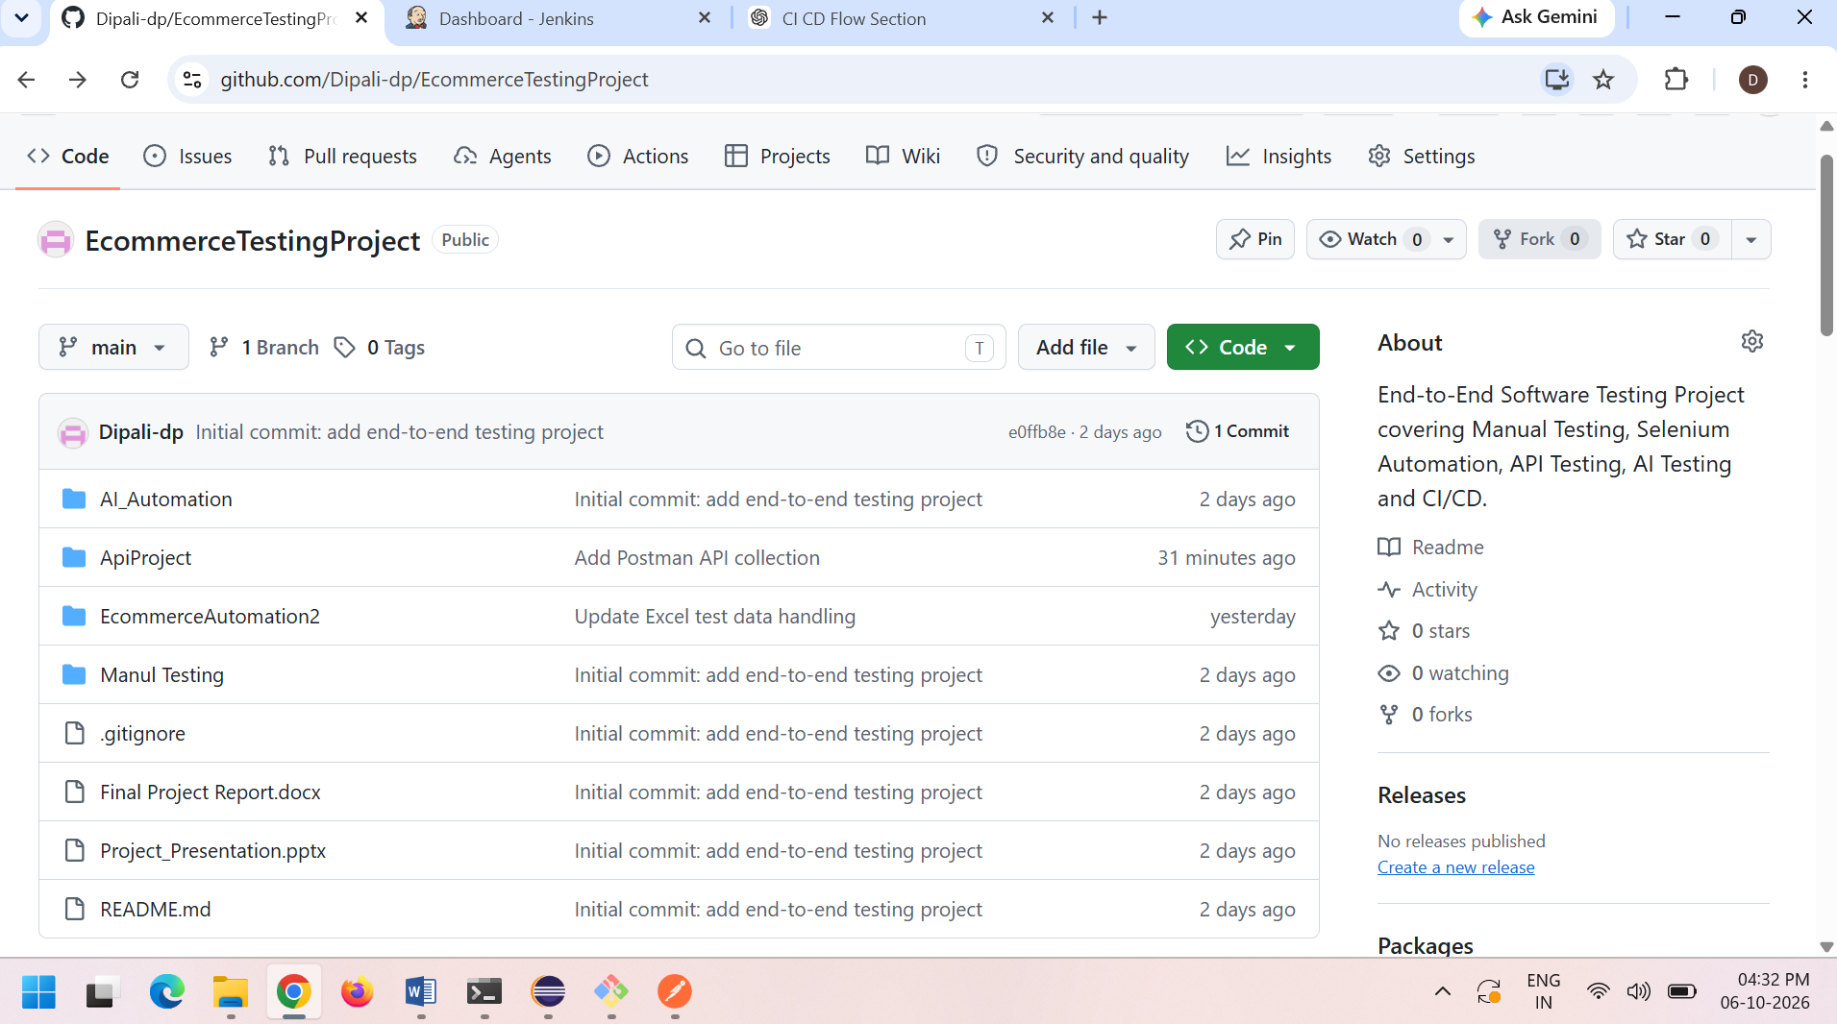

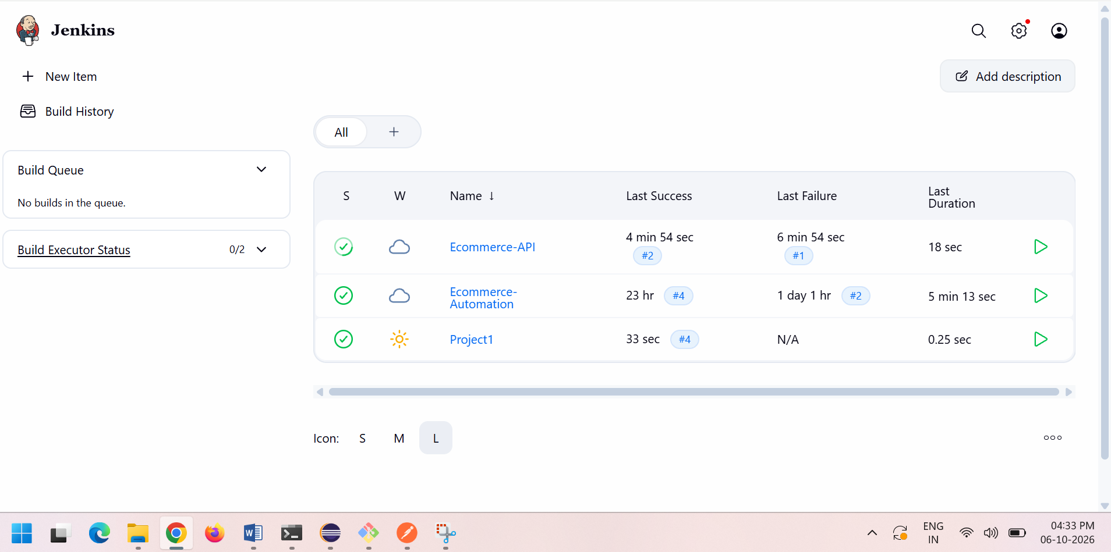

Challenges & Learnings

1. Challenges Faced
- Understanding and creating manual test cases for different e-commerce modules.
- Identifying and documenting functional issues during manual testing.
- Handling Selenium locators and synchronization issues during automation testing.
- Managing Page Object Model classes and maintaining reusable test methods.
- Validating API responses using Postman and Rest Assured.
- Understanding TestNG annotations and integrating automated tests with the Maven framework.
- Using Testim to record and execute an automated login test and perform Dashboard/Home validation.
- Managing test execution results and maintaining proper screenshots and test evidence.

2. Key Learnings
- Learned the complete Software Testing Life Cycle (STLC) and basic SDLC concepts.
- Gained practical experience in Manual Testing and test case preparation.
- Learned Functional, Positive, Negative, Regression, and UI Testing.
- Improved skills in Selenium WebDriver with Java and TestNG.
- Learned to implement the Page Object Model (POM) framework.
- Gained practical knowledge of API Testing using Postman and Rest Assured.
- Learned to validate API status codes, headers, and response data.
- Gained experience in AI-assisted test automation using Testim.
- Learned how to create an automated Login Test and Dashboard Validation using Testim.
- Improved understanding of test reports, screenshots, defect tracking, and test execution evidence.

3. Overall Learning
This project provided practical exposure to the complete testing process, from test planning and manual testing to automation, API testing, AI-assisted testing, and test reporting. It helped in developing practical QA skills and understanding how different testing tools and techniques are used in an e-commerce application.

